# **Code Output**

## **Initial Screen**

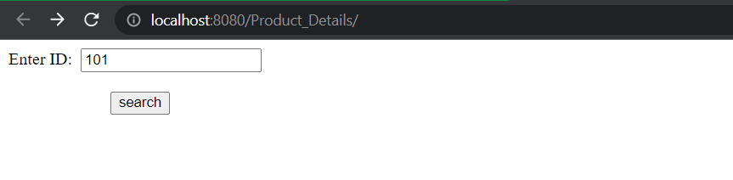

## **Result for valid Product ID**

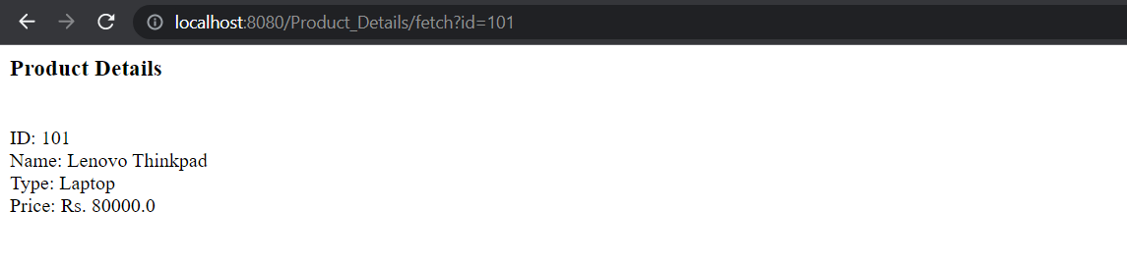

## **Result for invalid Product ID**

